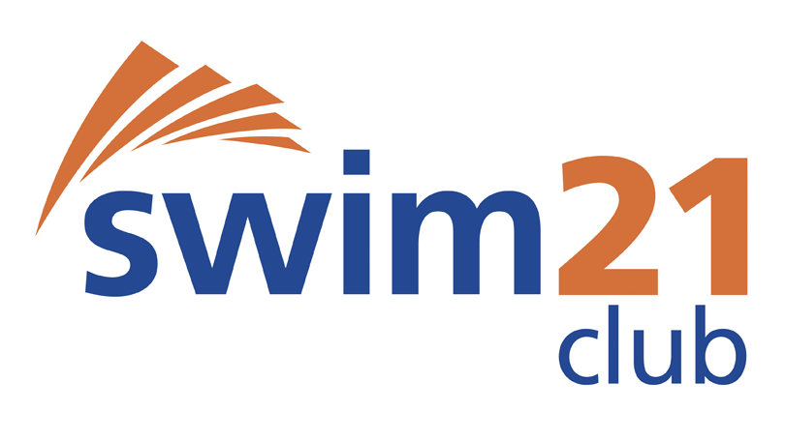

ASA Membership No |  |  |  |  |  |  |  |  | Forename (s) | Surname
Date of Birth |  |  |  |  | Age on 31/12/20 |  |  |  | Phone Number / Email | Gender | M/F

Entry for: Lancashire County Championships 2020
Date: 11th/12th January, 25th/26th January and 8th/9th February 2020
LICENSE: T.B.C

Event |  |  |  | Meet time achieved
 | Min | Sec | .00 |  | Day | Mth | Year
50 Freestyle
100 Freestyle
200 Freestyle
400 Freestyle
800 Freestyle
1500 Freestyle
50 Breastroke
100 Breastroke
200 Breastroke
50 Backstroke
100 Backstroke
200 Backstroke
50 Butterfly
100 Butterfly
200 Butterfly
100 IM |  |  |  | NOT AT THIS GALA
200 IM
400 IM
Total Number of Entries |  |  |  | Cost per Event £6.00  Coaches Pass £2.00  Please make cheques payable to  Garstang Swimming Club  Please write the swimmers and competition name on the reverse | £  £
 |  |  |  | Total Amount | £

CLUB CLOSING DATE Thursday 19th December 2019

I certify that the above entry times have been achieved in a licensed competition, in the qualifying period and accept that all entries for the above swimmer may be rejected if the times cannot be verified on the ASA Rankings.

SIGNED: …………………………………………………………………………………………………………………..DATE: ……………………………….

