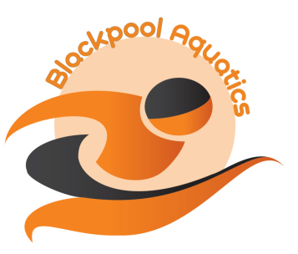
NORTH LANCS S&WPA LEVEL 3
1 DAY SPRINT MEET 16 JULY 2022
ENTRY FORM
License No: 3NW221306

FORENAME: | SURNAME:

ADDRESS:

 | POSTCODE:

PHONE:

EMAIL:

MALE/FEMALE  (delete as appropriate) | D.O.B.
SE ID NUMBER | AGE AT 16 JULY 2022

CLUB:

Please Note: Ages – 9 yrs, 10 yrs, 11 yrs, 12 yrs, 13 yrs, 14 yrs.

DISTANCE | STROKE | 25M POOL TIMES
50M | FREESTYLE
100M | FREESTYLE
50M | BACKSTROKE
100M | BACKSTROKE
50M | BREASTSTROKE
100M | BREASTSTROKE
50M | BUTTERFLY
100M | BUTTERFLY
100M | INDIVIDUAL MEDLEY

Number of Entries: |  | @ £4.00 | Total £

Club Closing Date:

MEET CLOSING DATE: MIDNIGHT MONDAY 4 JULY 2022

